Declaration of Original Work for CT2003 Assignment

We hereby declare that the attached group assignment has been researched, undertaken, completed, and submitted as a collective effort by the group members listed below.

We have honored the principles of academic integrity and have upheld Student Code of Academic Conduct in the completion of this work.

We understand that if plagiarism is found in the assignment, then lower marks or no marks will be awarded for the assessed work. In addition, disciplinary actions may be taken.

Name | Assignment  Group | Signature /Date
LWIN MOE OO | 5 | 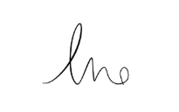
MUHAMMAD FIRDAUS BIN KAMARUDIN | 5
MURPHY WONG KAH LEONG | 5 | 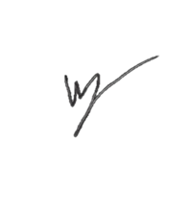
PANG WEI JIE | 5
PAZHANISAMY HARISH PRABHU | 5

Important notes:

Name must EXACTLY MATCH the one printed on your Matriculation Card.

Student Code of Academic Conduct includes the latest guidelines on usage of Generative AI and any other guidelines as released by NTU.

